Objective :

First Call Resolution (FCR) is the outcome (response variable) you are required to optimize. Provided datasets (June 2018 – Dec 2018) don’t contain this variable in it; you are required to create the response variable based on the below give definition. You can read more about FCR here-<https://www.thinkhdi.com/~/media/HDICorp/Files/Library-Archive/Insider%20Articles/First%20Contact%20Resolution.pdf>

First Call Resolution@3 (FCR@3) Definition:

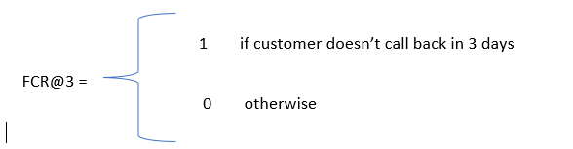

Steps to calculate FCR:

|  |  |  |  |  |
| --- | --- | --- | --- | --- |
| Customer_id | Date | Call_start_time | FCR@3 | Agent_name |
| 74231 | 20180602 | 07:24:35 | 0 | A |
| 74231 | 20180602 | 12:00:05 | 0 | B |
| 74231 | 20180602 | 17:45:09 | 1 | C |
| 12345 | 20180605 | 13:37:15 | 0 | F |
| 12345 | 20180606 | 09:25:56 | 1 | C |
| 34527 | 20180612 | 12:54:08 | 1 | B |
| 34527 | 20180629 | 08:12:45 | 1 | A |

a) Customer 74231 has called the contact centre 3 times on a single day, and there are no more calls from the customer after that for the next three days. We can assume that the problem of the customer is solved when the call is handled by agent “C”, who will be credited with the FCR@3= 1 and the other agents in the call leg “A” and “B” will be given 0.

b) Customer 12345 has called the contact centre two times in a span of two days. And there has been no call from the same customer after that for the next three days. “Agent C” will be credited with FCR@3= 1 and Agent F with 0.

c)There is no call back within 3 days from the customer 34527 for the two times he has contact the call centre. Hence, the two agents who answered the call for this customer will be credited with FCR@3 ==1

Why FCR?

Optimizing FCR would help the contact centre to pick right agents for a customer who would rectify his problems in the very first call. This would help the contact centre to provide great satisfaction to the customers and also, to reduce call volumes received everyday which in turn would help them to cut down call costs.

**Requirements:**

You are required to present the results in a ppt and also, to share the scripts used to generate the results. The presentation should cover/explain

1. Data pre-processing steps, irregularities in data if present any
2. Feature Extraction/creation/ Analysis steps
3. Evaluation metric selection criteria
4. Model Building steps
5. Model Validation, Evaluation steps
6. Feature Importance – Which of the features are more important for FCR estimation and why?

NOTE the audience will include non Data Scientists therefore the explanation should be in plain English. Assume approximately 30 minutes to present results and 15 minutes for questions